Chapter 11

Latest Developments Post AI Era

The AI Era in Azure Data Engineering
The landscape of data engineering on Azure has transformed rapidly in the wake of the AI era, driven by the advent of powerful large language models and AI assistants. Cloud data platforms are evolving to automate routine tasks, enable natural language interactions with data, and seamlessly integrate real-time intelligence and advanced analytics. Microsoft’s Azure data ecosystem – including Azure AI services and the Microsoft Fabric unified analytics platform – has introduced groundbreaking capabilities to meet these new demands. Organizations can now leverage AI agents, dynamic multi-agent pipelines, vector databases, and robust governance frameworks to accelerate data-driven insights while ensuring trust and security.
The emergence of advanced artificial intelligence technologies has transformed the landscape of data engineering, especially within the Azure ecosystem. This chapter explores the latest developments that are shaping the future of Azure Data Engineering post the AI era. It provides a comprehensive overview of cutting-edge services, agentic paradigms, real-time intelligence, and governance frameworks, all of which are enabling data engineers, architects, and developers to build scalable, intelligent, and secure solutions.

Structure of this chapter
This chapter is thoughtfully organised to highlight the profound influence of artificial intelligence on Azure Data Engineering. It opens by establishing the broader context, illuminating how AI-driven advancements have reshaped industry practices and introduced new possibilities for data professionals. The structure of this chapter is as below:
- The chapter begins by setting the context around the transformative impact of artificial intelligence on Azure Data Engineering, highlighting key advancements and their implications.
- It then provides in-depth coverage of newly introduced services, including detailed explanations of agent-based solutions and their roles in automating data processes.
- Subsequent sections delve into real-world applications, offering practical examples that illustrate how intelligent agents streamline tasks such as data ingestion, transformation, and analysis.
- The chapter also addresses emerging paradigms, such as real-time intelligence and governance frameworks, explaining their significance in creating scalable and secure data solutions.
- To support understanding, the chapter presents sample scripts and scenarios, giving readers actionable insights into implementing these technologies within the Azure ecosystem.
- Finally, the narrative concludes by reflecting on future directions and best practices for data engineers, architects, and developers in an AI-driven environment.

Objectives of this Chapter
- Clarify how artificial intelligence is transforming Azure Data Engineering, setting the stage for understanding the evolving landscape.
- Introduce and explain the latest Azure services, with a focus on agent-based solutions that enhance automation and efficiency in data workflows.
- Demonstrate practical applications through real-world examples, illustrating how intelligent agents simplify tasks like data ingestion, transformation, and analysis.
- Explore emerging trends such as real-time intelligence and governance frameworks, highlighting their importance for building scalable and secure data solutions.
- Provide readers with actionable insights, including sample scripts and scenarios, to guide the implementation of AI-driven technologies within the Azure ecosystem.
- Conclude with future outlooks and recommended best practices, equipping data professionals for success in an AI-centric environment.

Azure AI Agent Service
One of the most significant Azure innovations in the post-AI era is the Azure AI Agent Service – a fully managed platform for building and deploying AI-powered agents at scale. Announced in late 2024 and now part of the Azure AI Foundry portfolio, this service is designed to help developers create “smart” agents that can perform tasks, answer questions, and automate business workflows using the power of generative AI. In simpler terms, Azure AI Agent Service gives companies a way to stand up their own ChatGPT-like assistants or automation bots, tailored to their data and processes, without worrying about managing underlying infrastructure.
Azure AI Agent Service is a revolutionary offering designed to simplify and automate complex data workflows. By leveraging intelligent agents, this service orchestrates tasks such as data ingestion, transformation, and analysis, reducing manual intervention and improving efficiency. The agents are capable of interacting with multiple Azure services, adapting dynamically to changing data conditions, and ensuring seamless integration across the data ecosystem.
In this context, an agent is a microservice infused with AI that can observe and act. It uses a large language model (LLM) – like GPT-4 – to understand user instructions (in natural language), then takes actions or retrieves information by invoking tools, APIs, or databases. For example, an agent might intake a request like “Schedule a meeting with the team next week and draft an agenda”. The agent would use AI to interpret the request, then call the necessary services: check calendars, create a meeting invite, and even generate a draft agenda document. Azure AI Agent Service makes it much easier to build such an agent and have it reliably carry out these steps. Here is the reference architecture of Azure AI Agent Service to understand the ecosystem better.
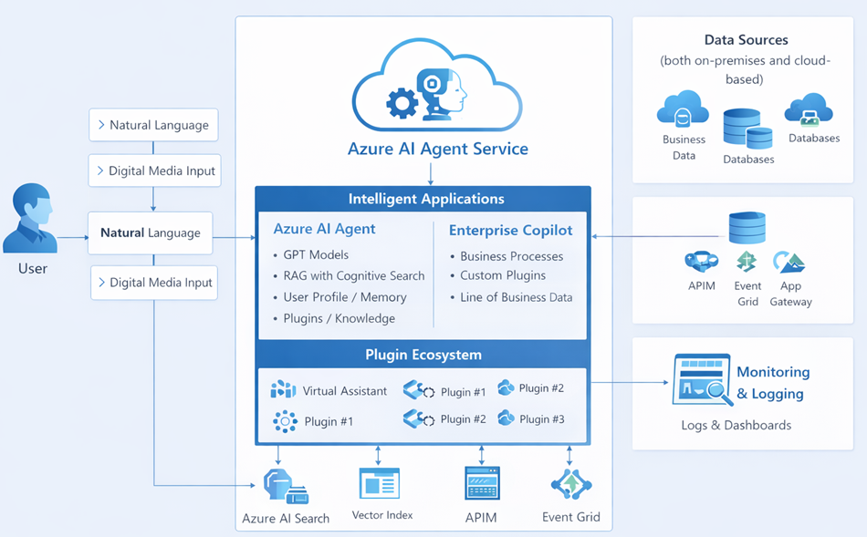
Figure: Reference architecture of Azure AI Agent Service
Key features of Azure AI Agent Service include:
- Simple Agent Development: Developers can define an agent with just a few lines of code or configuration. Using the Azure AI Python or .NET SDKs, one specifies the AI model to use (e.g. GPT-4), provides the agent’s instructions or prompt (defining its role and behavior), and registers any tools the agent can use. The service handles hosting the model and orchestrating tool usage for you.
- Integration with Azure OpenAI & Tools: Agents leverage the same API as Azure OpenAI “Assistants,” meaning they can natively use a wide range of tools and plugins. Over 1,400 Logic App connectors (to interact with SaaS apps, databases, etc.) are available, and agents can also execute Azure Functions (serverless code) for custom logic or data processing . This gives agents the ability to do things like interact with Microsoft 365 (Teams, Outlook, Excel), call internal APIs, run Python code for data analysis (in a sandboxed “code interpreter” environment), and much more.
- Multi-Modal and Extensible: Agents aren’t limited to text Q&A; they can perform transactions and workflow automation. Azure AI Agent Service supports connecting to external tools via OpenAPI specifications and can even extend open-source agent frameworks (like Microsoft’s Semantic Kernel or the LlamaIndex agent patterns) with cloud-scale capabilities. In practice, this means an agent can be endowed with new powers simply by adding a tool – for instance, giving it access to a SharePoint MCP endpoint (more on MCP shortly) to fetch documents, or a translation API to translate its outputs.
- Secure and Governed by Design: Because these agents might access sensitive corporate systems, Azure AI Agent Service emphasizes enterprise security. It runs within Azure’s trusted Foundry environment, uses Azure Active Directory for authentication, and can enforce OAuth 2.1 authorization flows and other governance policies automatically . Activity logs and error handling are standardized, making it easier to monitor what agents are doing – a crucial factor for building trust in AI automation.
Consider a scenario where an agent autonomously collects sales data from various sources, cleanses it, applies business rules, and generates actionable insights for business analysts. The agent can handle exceptions, notify stakeholders, and maintain logs for audit purposes.
Sample Agent Script:
# Pseudocode for Azure AI Agent Service
agent = AzureAIAgent()
agent.connect(source='SalesDB', target='AnalyticsLake')
agent.ingest()
agent.transform(rules='cleanse, deduplicate')
agent.analyse()
agent.notify('BusinessTeam')

Multi-Agent Orchestration in Azure
In traditional automation, a single script or service usually performs a defined sequence of steps. The emerging pattern of multi-agent orchestration is far more flexible: multiple AI agents, each with specialized skills, can dynamically collaborate to achieve complex goals. Azure’s ecosystem is embracing this concept, allowing organizations to design orchestrations of AI agents that pass tasks to each other, share context, and collectively solve problems that one agent alone couldn’t. This is especially powerful in data engineering and analytics scenarios, where different subtasks – data retrieval, analysis, documentation, decision-making – can be distributed among specialized agents.
Microsoft has introduced multi-agent capabilities through the integration of Fabric Data Agents with Microsoft Copilot Studio (the environment for building custom Copilot applications). In mid-2025, a preview was released that enables agent-to-agent communication using the Model Context Protocol (MCP) inside Copilot Studio. Put simply, an agent you create in Fabric (e.g., a data analysis agent) can “talk” to another agent in Microsoft 365 Copilot (e.g., an Office document assistant) via a standardized protocol, so they can coordinate actions.
It reflects how humans work in teams – complex workflows often require different experts or tools at different stages. By mimicking this, AI agents can achieve end-to-end automation of scenarios that span multiple systems. For instance, imagine a business process like “generate a sales report and schedule a review meeting”. One agent might be excellent at crunching the sales data, another at creating documents, and a third at handling calendar scheduling. Multi-agent orchestration allows these agents to hand tasks off seamlessly.
Multi-agent orchestration involves coordinating multiple AI agents to perform complex, interdependent tasks. In Azure, this is achieved using orchestration frameworks that manage agent communication, task allocation, and error handling. Agents operate both independently and collaboratively, enhancing scalability and resilience.
Multi-agent orchestration can be implemented using Azure Logic Apps, Durable Functions, or the Azure AI Agent Service. Each agent is assigned a specific role, such as data extraction or quality assessment, and the orchestration layer ensures smooth execution.
Example scenario: Microsoft illustrated this with a vision of an automated enterprise workflow:
- Agent A (Fabric Data Agent) – “Finance Data Agent,” which can pull real-time sales figures from the enterprise data lake (OneLake) and understand the data context (e.g., knows fiscal year definitions, sales hierarchies).
- Agent B (Office 365 Copilot) – a “Proposal Drafting Agent” in Word that can compose documents.
- Agent C (Microsoft 365 Assistant) – an agent that can schedule meetings in Outlook and update CRM entries.
This is illustrated as a workflow architecture in below diagram for your easy understanding.
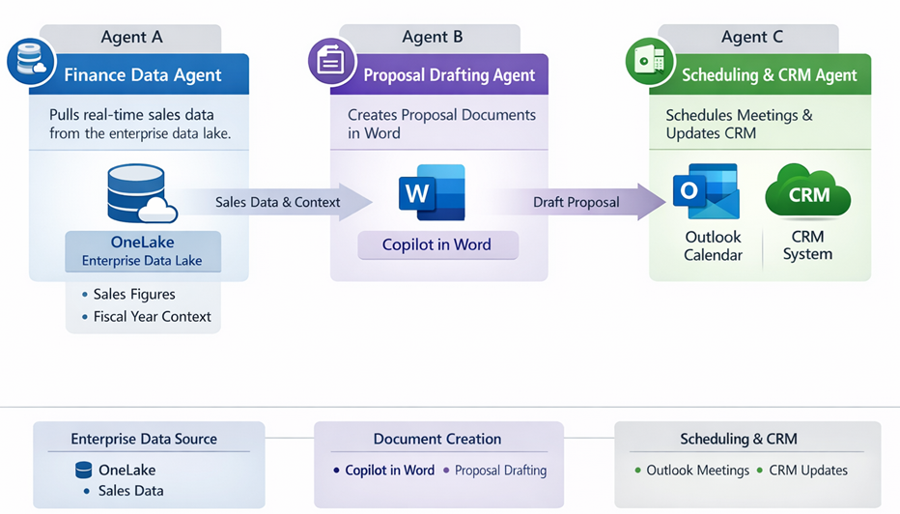
Figure: Automated Enterprise workflow architecture
The Finance Data Agent (Agent A) first gathers the latest sales numbers and perhaps performs some analysis (year-over-year growth, regional breakdowns). It then calls Agent B to draft a Word document: a sales proposal slide deck or report, embedding the data and insights Agent A provides. Once Agent B finishes the document, Agent C is engaged to email the report to stakeholders and put a follow-up meeting on everyone’s calendars. This kind of cross-agent handoff was not possible with earlier, isolated bots, but with Azure’s new multi-agent orchestration support, it becomes a reality.
The coordination is made possible by the Model Context Protocol (which we will detail later) and Azure’s Copilot Studio interface for chaining agents. In Copilot Studio’s orchestration designer, one can specify multiple agents and their interactions in a straightforward YAML or JSON configuration. For example, a YAML snippet below conceptualizes an agent orchestration with two agents: one Fabric data agent and one custom inventory agent, designed to work together in a supply-chain scenario:
1 agents:
2 - name: "SalesDataAgent" # Fabric Data Agent to fetch sales data
3 type: "Fabric"
4 endpoint: "https://api.fabric.microsoft.com/salesdata"
5 - name: "InventoryAgent" # Custom agent (perhaps using Azure Functions) to check inventory
6 type: "Custom"
7 logic: "AzureFunction"
In this setup, a SalesDataAgent might first retrieve the latest sales figures by calling Fabric’s data APIs, then invoke the InventoryAgent (via Copilot Studio’s orchestration) to ensure there is enough stock to fulfill incoming orders . Together, they automate a normally multi-step process: the sales agent provides context to the inventory agent, which checks inventory and maybe triggers a restock if needed.
This multi-agent pattern opens up a world of possibilities in data engineering and analytics:
- Cross-Domain Analytics: As noted in one analysis, Copilot can engage multiple data agents from different domains (finance, marketing, sales) in one conversation, “stitching together insights across business silos”. For example, an executive could ask a question that prompts separate agents to query finance data and sales data, then have the agents reconcile differences. The result is a more holistic answer than either data source alone could provide.
- Automated Data Workflows: Agents can coordinate to perform data pipeline tasks. One agent might extract and prep data from source systems, then signal another agent to load it into a warehouse or run a machine learning model. This dynamic approach can replace rigid ETL jobs with more adaptive, intelligent pipelines.
In summary, multi-agent orchestration in Azure acknowledges that no single AI model or agent can do everything. Instead, **multiple specialized agents can be orchestrated like an “AI team,” collaborating via Azure’s infrastructure. This concept is directly influencing how data pipelines are being built – moving us from static, predefined workflows to more flexible, agent-driven processes.
Here is a sample Orchestration Script to orchestrate multiple agents.
# Pseudocode for orchestrating multiple agents
orchestrator = AzureAgentOrchestrator()
orchestrator.add(agent1, task='ExtractData')
orchestrator.add(agent2, task='ValidateData')
orchestrator.add(agent3, task='EnrichData')
orchestrator.execute()

Agentic Data Pipelines
Traditional ETL/ELT pipelines are being replaced with agentic data pipelines in Microsoft Fabric. These pipelines employ AI agents to perform extraction, transformation, and loading tasks autonomously. Agentic pipelines are flexible, adaptive, and capable of responding to real-time changes.
The increased intelligence and autonomy of AI agents have given rise to what some call “agentic data pipelines.” These are data pipelines that think and adapt rather than just execute predefined steps. In traditional ETL (Extract-Transform-Load) or ELT pipelines, data engineers had to explicitly define every transformation and movement of data. The pipeline was essentially a fixed sequence of jobs (copy from source, clean the data, join it, load to target, etc.). If the source data changed – say a new column appeared, or an unexpected data quality issue arose – the pipeline might fail or produce incorrect results unless an engineer manually updated the logic.
Agentic data pipelines aim to harness AI agents to dynamically handle data ingestion and transformation tasks, reducing the need for constant human intervention. Microsoft’s recent acquisition of Osmos in January 2026 highlights this trend. Osmos was a startup focused on applying AI agents to data preparation, and Microsoft bought it specifically to embed those capabilities into Fabric’s data engineering layer. The goal is to simplify complex and time-consuming data workflows by having autonomous AI ingest, clean, and transform data in OneLake – essentially providing “autonomous data engineering” inside the platform.
To contrast the traditional vs. agentic approach, consider the following:
Traditional ETL/ELT Pipelines | Agentic AI-Driven Data Pipelines
Rigid sequence of predefined tasks (hard-coded transformations). | Dynamic sequence of AI-driven steps that can adapt at runtime.
Requires engineers to anticipate all data issues and schema changes up front. | AI agents detect anomalies or schema changes and adjust processing (or ask for guidance) on the fly.
Scaling requires significant manual coding and scheduling of jobs. | Scaling handled by agent platform – can spin up parallel agents as needed, with cloud-managed orchestration.
Limited ability to handle unstructured data or unforeseen scenarios without additional coding. | Naturally handles unstructured or varied data by leveraging language understanding (e.g., parses free text logs, JSON with unknown fields).
Primarily relies on human-defined rules for data quality (e.g., regex validations). | Can leverage AI for data quality – e.g., an agent can learn patterns to detect outliers or cleanse data (removing PII, standardizing formats) in more sophisticated ways.
Examples: A nightly job that copies CSV exports from one system to another and transforms column formats. | Examples: An AI agent that continuously monitors an API for new data, auto-maps incoming fields to a target schema using a learned mapping, fixes minor errors (like typos or unit mismatches) using a language model, and loads data into OneLake in near real-time.

The agentic pipeline thus behaves more like a human data engineer embedded in software: it can make decisions about how to handle the data. For instance, if there are missing values in a dataset, a traditional pipeline might drop those rows or fail – unless the developer explicitly coded an alternative. An agentic pipeline, however, could decide to fill in missing values by, say, calling an AI service to impute them or by asking a human for clarification if needed. This ability to reason and adapt is why we call it agentic.
Osmos’s technology (soon to be part of Microsoft Fabric) exemplified this by using AI to map and transform data from external partners into a company’s internal schema. Many companies receive data from external parties in various formats – aligning that to your database can be a tedious, ever-changing task. Osmos introduced AI data mapping agents that observe your data mapping rules and learn to automatically transform new datasets accordingly. For example, if you regularly pull sales leads from multiple partner CRMs, an Osmos agent could learn how each partner’s export file maps to your internal schema and perform the transformations, catching things like differing date formats or product code nomenclatures. It’s as if you have a junior data engineer who learns how to integrate new data sources by example. The agent can handle things like column matching, data type conversion, dropdown value mapping, and even apply semantic checks (e.g., flagging if a “Country” field contains an unexpected country name) – all with minimal human instruction.
Microsoft’s vision is that these AI-driven pipelines will drastically reduce the manual effort data teams spend on plumbing and cleaning. As the official announcement stated, “By integrating Osmos technology into Microsoft Fabric, we will help data teams turn raw data into analytics and AI-ready assets faster, reduce manual effort, and unlock more value from their data.”.
However, it’s important to note that agentic pipelines don’t eliminate the need for human oversight – they augment it. Data engineers will transition from writing every SELECT and JOIN by hand to supervising AI agents, validating their outputs and guiding them in edge cases. The benefit is that routine tasks (connecting to sources, handling minor schema drifts, basic anomaly detection) can be offloaded to AI, while humans focus on higher-level logic and governance. This synergy between human expertise and AI automation is a key hallmark of the post-AI era in data engineering.
In Microsoft Fabric, agents can monitor incoming data streams, apply transformations, and load results into analytical stores, all without explicit coding. This reduces development time and ensures pipelines are AI-ready.
Here is the example Agentic Pipeline pseudo code for Microsoft Fabric:
# Agentic pipeline in Microsoft Fabric
pipeline_agent = FabricDataAgent()
pipeline_agent.monitor('incoming_stream')
pipeline_agent.transform('auto')
pipeline_agent.load('OneLake')

MCP Integration with Multiple Data Sources
As AI agents proliferate, a major challenge is connecting them to the right data and tools in a robust, standardized way. Enter Model Context Protocol (MCP) – an open standard co-developed by Microsoft and the AI community (including companies like Anthropic) that has quickly gained traction as the “universal adapter” for AI integration . MCP’s motto is “connect once, integrate anywhere,” meaning that a data source or service only needs to implement an MCP-compliant interface one time, and then any AI agent (with an MCP client) can interact with it without custom coding.
In the MCP architecture, a Host (the AI agent or assistant) contains a generic Client component that knows how to speak the MCP protocol, and an external system (database, application, etc.) runs an MCP Server that exposes certain actions or data. The MCP server essentially wraps the external system’s API or queries into a standard format. When an agent needs something from that system, it sends a request via the MCP client, which the MCP Server receives, executes (e.g., runs a SQL query or fetches a SharePoint file), and then returns the results in a normalized format the agent can understand . The beauty is that once, say, a SQL Database MCP server exists, any compliant AI agent can query that SQL database without being explicitly programmed in T-SQL by the end user. The translations and security checks are handled by the MCP layers.
Microsoft has been rapidly building and encouraging MCP connectors for many data services:
- Official MCP servers exist or are in development for Azure services (to let agents manage Azure resources), GitHub (to let agents run repo operations), Playwright (for web browsing), Microsoft Teams (for collaborating in chats), Dev Box, and crucially Azure AI Foundry itself (giving agents access to all the tools in the Azure AI Studio).
- Third parties and open-source community have created MCP servers for systems like SQL Server, PostgreSQL, Google BigQuery, file systems, and even SharePoint. For example, a “SQL Server MCP” can safely expose specific tables or stored procedures to an AI agent, allowing the agent to run queries and get results. A SharePoint MCP could let an agent retrieve documents or search a SharePoint site in response to a user question (imagine asking an AI assistant to “find the onboarding guide in SharePoint,” and it uses MCP to fetch the file).
These MCP integrations solve a critical problem: how to give AI meaningful, secure access to enterprise data and tools. In the past, one had to custom-build each integration (with a lot of bespoke code and API handling). Now, developers can stand up an MCP server (or use a cloud-managed one) and then use it across many AI solutions. Microsoft provides SDKs (for example, an official C# MCP SDK) to simplify building these connectors, and even guidance on exposing existing REST APIs as MCP servers via Azure API Management (ensuring things like OAuth security and monitoring are in place).
To illustrate, let’s say a company wants its internal AI assistant to answer questions using data from an on-premises SQL Server and also allow certain actions in SharePoint. By deploying MCP servers – one for SQL Server and one for SharePoint – they can achieve this. The SQL Server MCP Server would expose, for example, a queryDatabase tool that accepts a T-SQL string and returns query results. The SharePoint MCP might expose a searchDocuments tool. The AI assistant (as the MCP Host) doesn’t need native knowledge of SQL syntax or SharePoint’s API; it will rely on the MCP client to intermediate. So when a user asks, “What were our top 10 products by revenue last quarter?”, the agent can translate this into a call to queryDatabase on the SQL MCP server. Later, the user might say, “Great, please upload this chart to the Portal” – the agent could then use the SharePoint MCP’s uploadFile or postDocument tool to save the chart to a SharePoint site, all in one seamless conversation. The MCP architecture handles authentication, encryption, error handling, etc., so that the developer didn’t have to write custom code for these integrations .
Going forward, MCP is likely to be the glue for connecting multiple data sources in agentic workflows. Indeed, the Visual Studio Magazine reported in late 2025 that Microsoft added an “Azure Cosmos DB MCP Toolkit” to tie its NoSQL database into Foundry Agent Service scenarios. This allowed AI agents to perform vector searches and transact against live Cosmos DB data, bringing operational database access into multi-agent systems. In short, MCP is making heterogeneous data access by AI as straightforward as calling a function – a huge leap for AI integration in complex enterprise environments.
Microsoft Cloud Platform (MCP) enables seamless integration with various data sources, including SQL Database and SharePoint. Data engineers can connect, extract, and unify data from disparate platforms, ensuring consistency and accessibility.
Here is the pseudo code script for MCP integration to connect to SQL database and Sharepoint.
# Connecting SQL Database and SharePoint
mcp_connector = MCPConnector()
mcp_connector.connect_sql('SalesDB')
mcp_connector.connect_sharepoint('Documents')
mcp_connector.unify()
Integration ensures that data from operational systems and document repositories is available for analytics, reporting, and AI-driven insights.

Evolution of Microsoft Fabric
Microsoft Fabric has evolved rapidly, introducing new features such as Fabric Copilot, Data Agents, and Copilot Studio. Fabric Copilot assists users in building data pipelines, generating code, and troubleshooting errors. Data Agents automate routine tasks, improving productivity. Copilot Studio offers a collaborative environment for designing, deploying, and managing AI-driven solutions.
Microsoft Fabric, introduced in 2023, began as a unified analytics platform bringing together data engineering, data warehousing, data science, real-time analytics, and business intelligence under one roof. In its initial preview, Fabric’s emphasis was on breaking down data silos – providing a single SaaS platform where you could do everything from extracting data to building Power BI dashboards, all stored in OneLake (Fabric’s cloud data lake). Fast forward to the post-AI era: Fabric has rapidly evolved into an AI-infused, full-stack ecosystem with built-in conversational Copilot features and agentic capabilities. Let’s look at this evolution:

As the timeline shows, Microsoft Fabric’s evolution has been marked by an increasing integration of AI capabilities:
- Copilot in Fabric: Users can interact with their data in natural language across the Fabric experiences. For example, in Power BI, Copilot can generate DAX measures or narrative summaries of a report. In Data Factory, Copilot can help generate pipeline expressions or suggest transformations. This makes advanced analytics accessible to a wider audience by reducing the need to write code. It also speeds up development for experts – one could ask, “In Fabric, generate a dataflow to join our sales and marketing data on customer ID”, and Copilot would draft the dataflow steps.
- Fabric Data Agents: These are essentially domain-specific conversational AI assistants for data. A Fabric Data Agent can be configured on top of a Lakehouse or Data Warehouse in OneLake with a semantic model. It understands the schema and business context, so a user can ask, for instance, “What were total sales in Europe last quarter, and how does that compare to the previous year?” and get a useful answer with charts or tables. The agent translates the question into a query (SQL or a Kusto query, depending on the engine) against the OneLake data, executes it, and uses the results to formulate a natural language answer or visualization . This feature, which builds on Power BI’s Q&A but enhanced with GPT-like flexibility, can dramatically lower the barrier to data analytics. Business users no longer need to drag-and-drop fields or write formulas; they can simply converse with their data.
- Copilot Studio and Custom Agents: Microsoft Copilot Studio (part of the broader M365 Copilot ecosystem) now allows organizations to create custom Copilot experiences – essentially tailored AI assistants – and connect them to resources like Fabric Data Agents. This was showcased in 2025 with the data agent integration, representing “a new era of multi-agent orchestration” . A company could create, for example, a “Finance Copilot” that not only answers questions using corporate financial data (via a Fabric data agent), but also connects to SAP to initiate budget adjustments and uses Outlook to draft emails for approval. Copilot Studio provides a canvas to wire these pieces together, and the underlying MCP ensures that the Copilot can call into the Fabric Data Agent as needed. The result is an AI assistant that is both conversational and action-oriented – able to discuss data and then take actions based on the data insights.
Microsoft Fabric’s journey in the post-AI era is all about infusing intelligence into every layer of the data stack. Users get AI-assisted tools (Copilot) to be more productive, and developers get an extensible framework (data agents + Copilot Studio with multi-agent support) to build entirely new AI-driven applications. The combination of a unified data foundation (Fabric’s core services) with generative AI (Copilot, agents) is positioning Fabric as a uniquely AI-ready analytics platform.

Advanced AI features in Azure OneLake
OneLake, Azure’s unified data lake, now includes advanced AI and security capabilities. AI features enable automated data classification, semantic tagging, and intelligent search. Security enhancements include role-based access, encryption, and anomaly detection.
At the heart of Microsoft Fabric is OneLake, the “one lake for all your data” analogous to OneDrive for files. OneLake provides a single, multi-cloud data lake that is automatically available to every Fabric user and service. In the post-AI era, several new OneLake features have been introduced to enhance how data is accessed, secured, and made AI-ready:
- Unified Access to Data (Shortcuts & Zero-Copy): OneLake introduced data shortcuts, which are pointers to external storage locations. This allows Fabric to virtually connect to data on other cloud storage or on-premises, without moving or duplicating the data. For instance, a shortcut can link an S3 bucket or an ADLS Gen2 container into OneLake, so that Fabric analytics can query it as if it were local. This zero-copy approach reduces data sprawl and ensures that AI or BI tools are always accessing the single source of truth. In parallel, Fabric’s new Mirroring feature (discussed in the next section) enables replicating certain operational data into OneLake in near real-time with minimal effort.
Here is the reference architecture of Azure OneLake with latest features for AI-ready services integrated for unified data solutions.
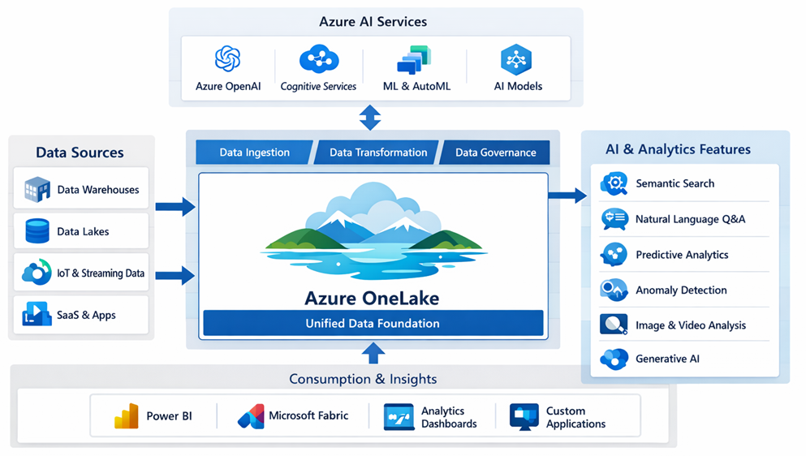
Figure: Reference architecture of Azure OneLake

- Open Data Formats for AI Compatibility: OneLake stores data in open, standard formats such as Delta Parquet and Apache Iceberg tables. By standardizing on these formats, Fabric ensures that all its compute engines (Spark, SQL, Data Science notebooks, Real-Time Analytics, Power BI) can operate on the same copy of data without conversions. This is crucial for AI scenarios: for example, you might build a machine learning model from curated Parquet data with Spark, and deploy it, but later run real-time predictions on streaming data using Kusto (which can also read from the same Parquet files). A single copy of data in OneLake serves many engines, simplifying governance and eliminating consistency issues. Data scientists and analysts can be confident they’re all working on the latest, centralized data.
- Granular OneLake Security (Unified RLS and CLS): Perhaps the most groundbreaking update is OneLake Security, which provides centralized role-based security definitions at the data lake level. Traditionally, each tool had its own security – e.g., Power BI had row-level security defined within datasets, SQL pools had GRANTs on tables, Spark might rely on ACLs or filtering logic. This could lead to inconsistent enforcement.
With OneLake Security, a data owner can define fine-grained permissions once on the folders, tables, or even rows/columns in OneLake, and those rules will be enforced uniformly by all Fabric components . For example, a data engineer could specify that only certain roles can see rows where Department=="Finance" or mask out the Salary column for all but HR managers. If that data is accessed in a Spark notebook, a SQL query, or a Power BI report, the OneLake Security layer will ensure the restriction is applied in each case. This dramatically reduces the risk of inconsistent permissions and simplifies the security management overhead. OneLake is a game-changer for organizations that struggle to maintain data compliance across different tools.
- Integration with Microsoft Purview for Governance: Alongside OneLake Security, Microsoft has bolstered Purview’s integration with Fabric. Purview is Microsoft’s data governance and catalog service. Updates in late 2025 allow Purview to scan and index Fabric’s datasets, lakehouses, and other artifacts for classification and lineage tracking.
The OneLake data catalog (accessible in the Fabric portal) is powered by Purview and gives all users the ability to discover data assets, see their schema and descriptions, and understand their lineage (where the data comes from and how it’s been transformed) in a single interface . This unified catalog is critical in the AI era: it helps ensure that when AI is used to answer questions or drive decisions, it’s referencing trusted, well-documented data. Moreover, Purview’s sensitivity labels and data loss prevention (DLP) policies can now be applied to Fabric data.
For example, if a column is tagged as Confidential, Purview can prevent an AI Copilot from revealing that information in a chat response (by either masking it or blocking the answer) . This kind of integration between data governance and AI is part of Microsoft’s strategy to enable responsible AI use – we’ll touch more on AI governance later.
- AI-Ready Data Sharing and Collaboration: OneLake not only centralizes an organization’s data but also makes it easier to share data across team boundaries with control. Fabric introduced the concept of domains and workspaces within OneLake to mirror organizational structure and ownership boundaries . Data can be shared via shortcuts or direct links, and because of the unified security and catalog, a data scientist in one department can safely discover and request access to another department’s dataset for a machine learning project. This fosters collaboration on AI projects, breaking down silos while still allowing domain-specific governance.
Overall, OneLake’s new features position it as a foundation for AI in the enterprise: a single place where all data lives (or is at least virtualized), where it’s stored in open formats accessible by AI/ML tools, and where consistent security and governance guardrails are in place to prevent misuse of that data.
Sensitive financial records are automatically classified, tagged, and access-controlled. Anomalies in access patterns trigger alerts, ensuring data protection.

Mirroring Databases to OneLake
Azure now supports mirroring of databases such as Azure SQL Database, Cosmos DB, and PostgreSQL to OneLake. This eliminates the need for complex ETL processes, allowing real-time synchronisation and simplified analytics. This is explained in below reference architecture diagram.
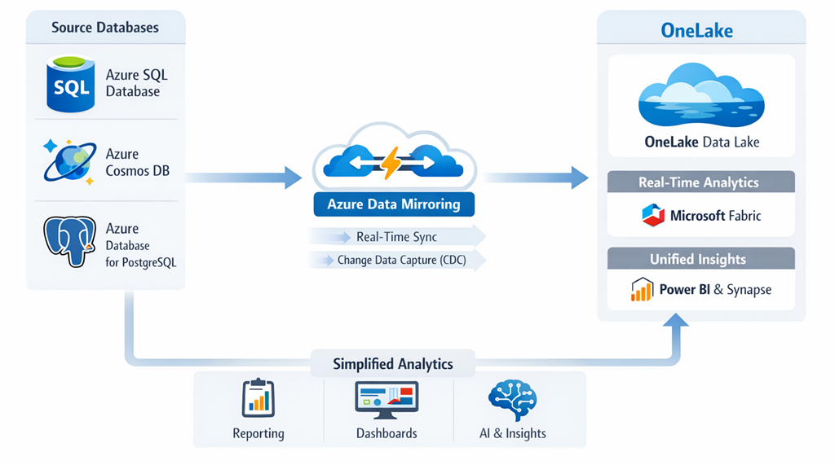
Figure: Real-time synchronisation in Azure Data Mirroring
Following on the theme of eliminating data silos and reducing ETL work, Microsoft introduced Fabric Mirroring – an approach often described as “zero-ETL” ingestion. The idea behind mirroring is to enable real-time replication of data from operational databases into OneLake with minimal effort and without building complex pipelines. Currently, Fabric supports mirroring from sources like Azure SQL Database, Azure Cosmos DB, Azure PostgreSQL, and even Snowflake, with more on the roadmap .
When you set up a mirror, Fabric creates a connection to the source database and automatically manages the initial snapshot and continuous change capture. Under the hood, it often uses technologies like change feeds or transaction logs – for example, Cosmos DB’s change feed or SQL’s Change Data Capture (CDC) – to stream changes from the source into OneLake in near real-time. The data lands in OneLake as Delta tables (Parquet files) within a special Mirrored Lakehouse that corresponds to your source database. Both the data and schema are kept in sync, so if new tables or columns are added to the source, the mirror can reflect those changes automatically . This is a stark contrast to traditional ETL, where schema changes would require manual pipeline modifications.
Because the mirrored data is stored in Delta/Parquet format, it becomes immediately queryable by Fabric’s engines in a high-performance way. Microsoft notes that this unlocks scenarios like using Direct Lake mode in Power BI – bypassing import or direct query – since the data is already in the lake in a columnar format . The end result is the ability to run analytics or AI on live operational data without complex ETL jobs.
Example scenario: A retail company wants to analyze sales transactions stored in an Azure SQL Database and combine them with customer data from Azure Cosmos DB (NoSQL). Normally, they would build a pipeline to regularly export data from these two systems, transform and join it in a data warehouse or data lake. With Fabric Mirroring, they can set up mirrors for both the Azure SQL DB and the Cosmos DB (via its API for MongoDB, for instance). Fabric will create and manage two mirrored lakehouses in OneLake, one for each source. As transactions occur in the SQL database and new customer records appear in Cosmos, those changes are automatically and continuously applied to the OneLake Delta tables . Analysts and data scientists can then perform queries across the two mirrored datasets within Fabric. For instance, a single T-SQL query could join sales orders from the SQL mirror with customer info from the Cosmos DB mirror to produce a unified report – something that historically required exporting and merging data from separate systems. Mirroring thus enables a near-real-time, unified view of data across disparate stores, with Fabric acting as the hub.
To optimize performance and minimize overhead, Mirroring uses cloud-native change feeds. The initial load brings over all historical data, and then only the deltas (new or changed records) are continuously synchronized. This is efficient and keeps OneLake updated almost live. As a bonus, since the data is already in OneLake, advanced analytics and AI models can be applied immediately. You could, for example, run a Fabric data science notebook to train a machine learning model on the latest sales and customer data without building a separate data export. Essentially, mirroring “replaces the ‘E’ (extract) in ETL” – data integration experts have noted that it provides built-in continuous extraction so you can focus on the transformation and analysis.
Handling schema changes and errors
Mirroring is built to be resilient. If the source schema changes (like a new column added), the mirror can propagate that change to OneLake without breaking the pipeline. And if there’s an issue (say the destination is unreachable), Fabric provides monitoring and status of the mirror in the workspace, so you can see lag or errors and address them. This reduces the maintenance effort compared to custom ETL, where engineers often don’t find out about failures until someone notices missing data.
Current limitations
Mirroring is still a relatively new feature (introduced in preview in late 2024 and reaching general availability by 2025). It initially supports Azure sources (SQL DB, Cosmos, PostgreSQL, etc.) and some external databases like Snowflake, with more to come. It also requires Fabric’s premium capacity and certain configurations (for example, Azure SQL DB must not have certain features like its own CDC or Synapse Link enabled, to avoid conflicts). Despite these limitations, the promise of eliminating ETL for many scenarios is extremely attractive. In one blog, the author calls mirroring “game-changing… ensuring your data is always up-to-date for advanced analytics, AI, and data science, all without the complexity of traditional ETL processes”.
By using mirroring in conjunction with other OneLake features (like shortcuts for external data and the unified security model), organizations can significantly simplify their data architecture. Data from operational stores flows into the analytics lake in (near) real time, ready to be consumed by BI reports, SQL or Spark queries, and machine learning models – without writing a single data pipeline. This drastically shortens the time it takes to get value from data, supporting real-time decision making and AI applications like up-to-the-minute personalized recommendations or anomaly detection on live business operational data.
Mirroring Script Example:
# Mirroring Azure SQL Database to OneLake
mirror_service = AzureMirror()
mirror_service.source('AzureSQL')
mirror_service.target('OneLake')
mirror_service.enable_realtime()
This capability streamlines data consolidation and supports event-driven architectures.

Real-Time Intelligence (KQL)
Azure provides real-time intelligence through Kusto Query Language (KQL), which powers event-driven analytics. Data engineers can analyse streaming data, detect patterns, and generate alerts instantly.
Modern enterprises increasingly need to analyze data as it’s generated, whether it’s server logs, IoT sensor readings, or transactional events. Recognizing this, Microsoft Fabric includes a Real-Time Analytics (RTA) capability – recently rebranded as Real-Time Intelligence – which is essentially a streaming data platform built into Fabric. In the post-AI era, real-time data streams are not just for operational dashboards; they’re feeding directly into AI systems that perform instantaneous analysis, anomaly detection, and decision-making.
A cornerstone of Fabric’s Real-Time Intelligence is its use of KQL (Kusto Query Language), a powerful query language originally developed for Azure Data Explorer (Kusto) and widely used in analytics services like Azure Monitor. KQL is known for its ability to perform blazing-fast aggregations and filtering on large append-only datasets (like logs and time-series data). In Fabric, KQL is the language used to query streaming data in what’s called an Eventstream or Eventhouse, which are components of the Real-Time Analytics offering .
Here’s how it works in Fabric’s Real-Time Intelligence (RTI) with a reference architecture as shown in below diagram.
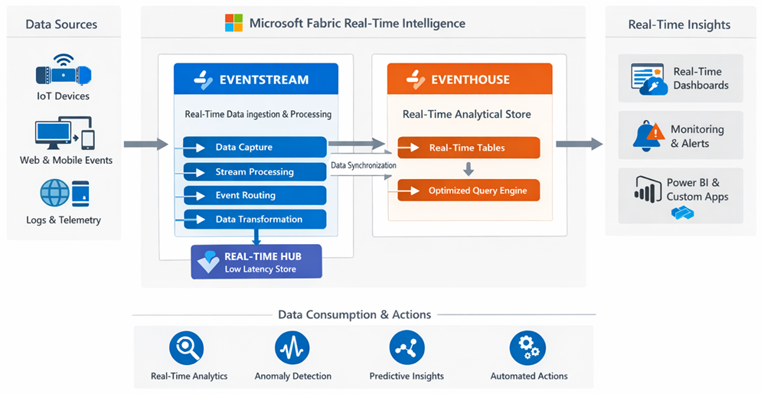
Figure: Reference architecture of Microsoft Fabric Real-time Intelligence (RTI)
- Eventstream: A pipelined service that ingests and processes streaming events. It can connect to numerous sources (via built-in connectors) such as Azure Event Hubs, IoT Hub, Kafka, Amazon Kinesis, MQTT brokers, database CDC feeds (SQL, Cosmos DB, PostgreSQL), and even Fabric’s own internal events . Eventstreams allow you to do streaming ETL – filter or aggregate events on the fly, perform windowing operations, etc., all in a no-code interface if you like. For instance, an Eventstream could ingest clickstream data from a website and compute a rolling 5-minute window of active users by region.
- Eventhouse: A storage and query engine optimized for time-series and log data. Under the covers, Eventhouse is powered by the Kusto engine (the same technology behind Azure Data Explorer and Log Analytics). It automatically organizes incoming data by time, partitions it, and creates indices to allow sub-second queries on high-volume data . Data in an Eventhouse is queryable with KQL, which is well-suited for these scenarios (KQL has succinct syntax for filtering by time ranges, computing moving averages, etc.). Moreover, the data in an Eventhouse can be exposed to other Fabric experiences – for example, you could create Real-Time Dashboards (a new type of Power BI report in Fabric) to visualize streaming data with live updates, or even join real-time data with historical data in a Fabric warehouse.
Event-driven analytics powered by KQL enables use cases like real-time anomaly detection and alerting. For example, consider an IoT scenario: a manufacturing company streams temperature sensor readings from equipment into Fabric. An Eventstream brings in the sensor data from IoT Hub, filters and aggregates it, and lands it in an Eventhouse in real time. An analyst (or an AI agent!) can then write a KQL query to detect anomalies, e.g., find when temperature jumps more than 5 degrees in 1 minute. KQL’s expressive syntax makes this straightforward:
1 EventStreamData
2 | where machine_id == "MachineA"
3 | where TemperatureChange > 5 and AlertSent == false
4 | project Timestamp, machine_id, Temperature, TemperatureChange
This query would continuously evaluate the stream of temperature readings for “MachineA” and output those that meet the anomaly criteria (a jump >5°C and no prior alert sent). The result could feed a Real-Time Dashboard for operations monitoring.
But you can go further – Fabric’s Activator allows trigger-based actions on data streams . For instance, you could configure an Activator to watch for any output of the above query and automatically perform an action when a row appears.
The action could be sending an alert to a team via Teams or email, invoking an Azure Function to attempt an automatic fix (like shutting off a machine that’s overheating), or even calling an AI agent to analyze the situation. In our example, when a large temperature spike is detected, an Activator could trigger an AI Copilot to message the plant manager with a suggested remediation plan – perhaps even ordering a maintenance crew to check the machine, after the AI analyzes historical data of similar incidents.
Additionally, Real-Time Intelligence is integrating with Digital Twins and geospatial analysis. There’s a Digital Twin builder in Fabric that uses a low-code approach to model physical environments (like factories or IoT device networks) and map streaming data to those models .
For instance, you could model a factory floor as a digital twin (with entities like machines, rooms, sensors) and then map the IoT streams to those entities, enabling complex event processing like “if any machine in Room A overheats, notify maintenance.” On the geospatial side, Fabric introduced new Map visualizations that can display real-time data on maps – useful for scenarios like fleet tracking or regional monitoring of events (with support for custom map layers, geocoding, etc.).
In essence, Fabric’s Real-Time Intelligence brings streaming data into the AI era by providing the tools to not only analyze data in motion using KQL and visualization, but also to respond immediately using automation.
From a data engineering perspective, it means the traditional boundary between “batch ETL vs. streaming” is blurring – important insights can be derived and acted upon in seconds, which is particularly critical for AI applications that rely on up-to-the-moment data (think of an AI-driven recommendation engine adjusting to customer behavior in real time, or an anomaly detection model catching a cybersecurity threat as it happens).
The combination of KQL, real-time pipelines, and AI-driven actions enables what Microsoft terms Real-Time Intelligence – the ability to derive and apply intelligence at the speed of events.
Consider a practical scenario in Monitoring IoT devices, detecting anomalies, and updating dashboards in real-time and here is a KQL Example code for the scenario:
# KQL query for real-time event analysis
IoTEvents
| where Temperature > 80
| summarize count() by DeviceID, bin(TimeStamp, 5m)

GraphRAG in Azure Database for PostgreSQL
GraphRAG is an advanced framework for leveraging graph-based retrieval augmented generation in Azure Database for PostgreSQL. It combines graph traversal with AI models to provide richer, context-aware results.
As organizations adopted Retrieval-Augmented Generation (RAG) techniques – where LLMs use external data sources to ground their answers – new challenges emerged around accuracy. Simple keyword search or vector similarity search can falter when the data is large or highly interrelated. In 2024, Microsoft researchers and engineers proposed GraphRAG as an advanced method to boost the precision of RAG systems by incorporating graph knowledge into the retrieval process. Azure Database for PostgreSQL became a prime platform to implement this, thanks to its support for both vector searches and graph queries via extensions.
GraphRAG (Graph-enhanced Retrieval-Augmented Generation) is a technique that supplements vector similarity search with graph-based context. In a typical RAG pipeline, say for a Q&A bot, you might embed your documents and use a vector database to fetch those most relevant to the user’s question. GraphRAG suggests that if your data has an inherent graph structure (relationships between entities), leveraging that structure can yield better retrieval results, thereby improving the accuracy of the answers the LLM generates .
Azure Database for PostgreSQL (especially the Flexible Server offering with the Hyperscale variant) supports Postgres extensions like https://learn.microsoft.com/en-us/azure/postgresql/flexible-server/concepts-vector-search (for vector similarity search) and Apache AGE (for graph database functionality using openCypher queries). This means a single database can act as a relational store, a vector store, and a graph store simultaneously – a very powerful combination for building a GraphRAG system .
Microsoft’s sample solution (released as a public preview in November 2024) focused on legal documents. They had a corpus of judicial cases, which naturally reference each other (case A cites case B, etc.), forming a web of legal precedents. They ingested ~500,000 legal case documents into Azure Database for PostgreSQL. Using pgvector, each document was embedded into a vector for semantic search, and using Apache AGE, the citations among cases were stored as a graph in the same database. A GraphRAG-based retrieval pipeline then worked in three stages for any user query:
- Semantic Vector Search: First, a standard vector similarity search finds candidate documents related to the query (for example, retrieving 50 legal cases that might be relevant, based on embeddings of the query and cases). This is done with a simple SQL query using the <=> vector similarity operator provided by pgvector – under the covers, Azure’s pg_diskann index (if enabled) accelerates this search. For example, this returns the top 50 candidate cases for the question, based on neural embedding similarity.

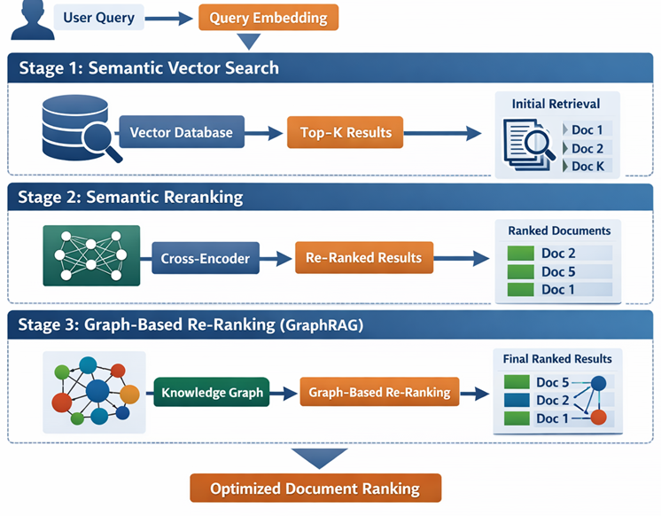
Figure: GraphRAG stages

- Semantic Reranking: Next, the system re-ranks those 50 results using a semantic ranker model (another AI model that scores relevance more accurately, possibly by deeper linguistic analysis) . This step (which can also be done in Postgres via a custom function or in the application layer via an Azure AI service) improves the relevance of the retrieved set, bringing truly pertinent documents to the top.
- Graph-based Re-ranking (GraphRAG): Finally, GraphRAG comes into play. The idea is to use the knowledge graph of case citations to adjust the ranking of results. In the legal domain, the number of times a case is cited by others is a measure of its importance or “prominence.” So among the semantically relevant cases from step 2, the GraphRAG pipeline runs a graph query (using openCypher via Apache AGE in Postgres) to calculate a score for each case based on how connected or prominent it is in the citation network . In practice, they might count how many times each candidate case is cited by other top candidates, or use algorithms like Reciprocal Rank Fusion that combine semantic similarity rank and graph centrality. The result is a re-weighted top 10 list of cases that are both relevant and highly cited.
Those top results are then fed to the language model to generate the final answer (e.g., a summary of the key legal precedents for the question). The outcome was a significant improvement in accuracy. The GraphRAG-enhanced system was better at selecting authoritative cases, reducing the risk of the LLM quoting irrelevant or less important documents. In Microsoft’s tests, the combination of vector search + semantic ranker + GraphRAG outperformed vector search alone by a wide margin in terms of retrieving the “golden” relevant documents for a query .
While the legal use case was a natural fit (due to pre-existing graph structure of citations), the approach is general. Enterprises can use it wherever relationships matter: think of knowledge graphs linking concepts (products, customers, etc.), or connections between people and departments. Azure Database for PostgreSQL provides an ideal playground for this because you can store data and relationships in one place.
For example, one could ingest a collection of research papers, use a vector search to find relevant papers for a query, but then use a graph of citations or even a knowledge graph of topics to refine the results further. The fact that all this can be done “inside” Postgres, with SQL and graph queries combined, is both convenient and powerful – it reduces architecture complexity (no need to maintain a separate graph database or separate vector store).
GraphRAG is a prime example of how AI and data engineering are intersecting in new ways. Data engineers are now thinking beyond flat tables and considering graph structures and hybrid techniques to support AI applications. As of 2024–2025, GraphRAG was provided as an open-source solution accelerator for Azure PostgreSQL, and we can expect such techniques to be incorporated into more products (or even automated by AI agents) in the near future.
Implementation Example:
# GraphRAG in PostgreSQL
SELECT graph_rag_query('SELECT * FROM nodes WHERE ...');
This approach supports complex knowledge discovery and semantic search.

DiskANN Vector Search (GA) in Azure
The explosion of AI applications – particularly those using embeddings and semantic search – created a need for database systems that can handle vector data efficiently. Vectors (numerical arrays representing semantic meaning of text, images, etc.) are now a first-class citizen in data engineering. Recognizing this, Microsoft has integrated vector search capabilities into its core data services, notably Azure Cosmos DB and Azure Database for PostgreSQL. The “latest developments” here revolve around the general availability of DiskANN, a cutting-edge vector indexing algorithm, in these platforms.
It’s a Disk-based Approximate Nearest Neighbour search library originally developed by Microsoft Research for Bing’s web-scale image search. Traditional vector search methods (like HNSW) keep indexes in memory, which becomes very expensive as vector collections grow into millions or billions of items. DiskANN cleverly stores the index on disk (SSD) in a graph structure optimized for minimal disk seeks. Here is a reference architecture of how DiskANN can be visualized in Microsoft solution for Vector search approach with Azure native data store.
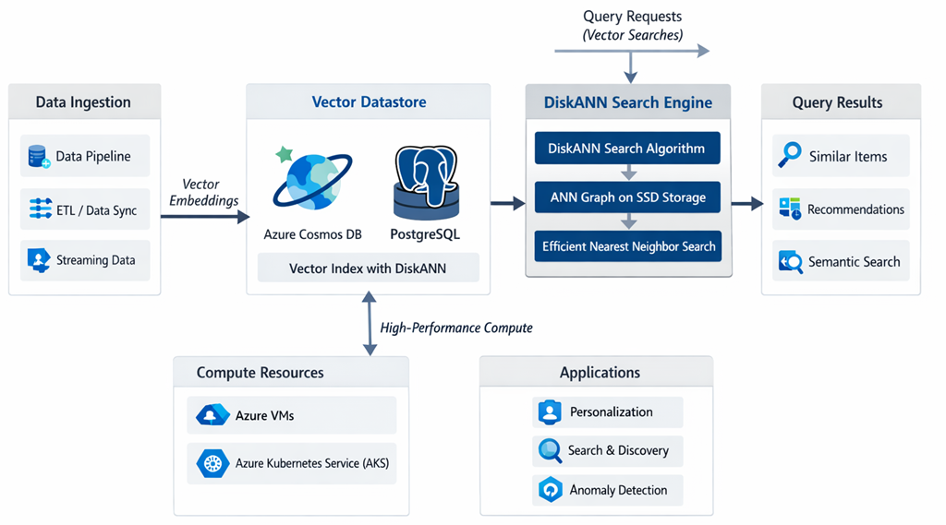
Figure: Reference architecture of DiskANN with Azure native data store
It yields extremely fast search (low latency) even for very large datasets, without requiring enormous RAM. Microsoft reported that, compared to the widely used HNSW approach, DiskANN delivered comparable accuracy with 10× higher throughput, 4× lower cost, and up to 96× reduction in memory usage on a 35-million vector dataset . These are staggering improvements, making it feasible to integrate vector search into operational scenarios at scale.
Azure Database for PostgreSQL: Microsoft added DiskANN as the pg_vector extension pg_diskann in Azure PostgreSQL (currently available in the Flexible Server model). Developers can enable it with a simple SQL command (CREATE EXTENSION pg_diskann CASCADE; which also brings in the base vector type) . Once enabled, you can create a special DiskANN index on a vector column, just like creating an index on a traditional table. For example, if you have a table of products with an embedding vector column, you can do:
1 CREATE INDEX product_embedding_idx
2 ON products
3 USING diskann (embedding vector_cosine_ops);
This creates a DiskANN index (optimized for cosine similarity) on the embedding column of the products table . Now you can perform similarity searches. For instance, to find the top 5 products most similar to a given vector, you might run:
1 SELECT product_id, product_name
2 FROM products
3 ORDER BY embedding <=> '[0.12, 0.03, ... , -0.07]'::vector
4 LIMIT 5;

Note: Here '<=>' is the operator for vector distance (a smaller distance means more similar) and the query vector (in brackets) would be a
DiskANN Vector Search is now generally available in Azure Cosmos DB and PostgreSQL, enabling high-performance, scalable vector similarity searches. This is crucial for AI applications such as recommendation systems and semantic search.
For example,, an e-commerce platform solution can use DiskANN to recommend products based on user behaviour vectors. This is next level of Lead generation for Customer Relationship Management (CRM).
Example Query:
# DiskANN vector search example
SELECT * FROM products WHERE DiskANN(vector) > threshold;

Vector Store/Database Integration with ADF
Azure Data Factory (ADF) now supports integration with vector stores and databases. This allows data pipelines to perform semantic enrichment, similarity searches, and AI-driven transformations.
Pipeline Example:
# Integrating vector store in Azure Data Factory
pipeline = DataFactoryPipeline()
pipeline.add_step('Extract')
pipeline.add_step('VectorStoreEnrich')
pipeline.add_step('Load')
Such integration ensures that data is AI-ready for downstream applications.

Creating AI-Ready Pipelines
Building AI-ready pipelines requires attention to data quality, lineage, and semantic consistency. Azure tools provide automated validation, lineage tracking, and semantic tagging to ensure that data is accurate, traceable, and meaningful.
Example: A pipeline uses validation agents to check for missing values, lineage agents to track data origins, and semantic agents to tag entities.
Sample Code:
# AI-ready pipeline with quality and lineage
pipeline = AIReadyPipeline()
pipeline.validate('quality_rules')
pipeline.track_lineage()
pipeline.semantic_tag('entities')

AI Governance (TRiSM)
AI Governance is vital for ensuring responsible, transparent, and secure use of AI in data engineering. Azure’s TRiSM framework (Trust, Risk, Security, Management) provides guidelines and tools for establishing governance policies, monitoring compliance, and managing risks.
A financial institution implements TRiSM to ensure that AI models are audited, data is protected, and decisions are explainable.
Governance Script Example:
# Applying TRiSM governance
trism = AzureTRiSM()
trism.audit('AIModels')
trism.secure('SensitiveData')
trism.monitor('Compliance')

Conclusion
The post-AI era in Azure Data Engineering is marked by intelligent agents, autonomous pipelines, and robust governance. Data professionals must embrace these innovations, focusing on automation, real-time intelligence, and responsible AI practices. Staying updated with Azure’s evolving ecosystem will ensure that solutions remain scalable, secure, and impactful. Some best practices in adopting AI infused Data Engineering in Azure platform listed below:
- Adopt agentic pipelines for flexibility and resilience
- Integrate diverse data sources using MCP
- Leverage real-time intelligence for timely insights
- Ensure data quality and lineage for AI readiness
- Implement TRiSM for trustworthy AI governance
With these principles, data engineers, architects, and developers can confidently navigate the next phase of Azure Data Engineering.

